©® ©®

**EFRUZHU ABSOLUTE ANY STAGE ONCOTHERAPY DISCOVERY**

|  |  |  |  |  |  |  |  |  |
| --- | --- | --- | --- | --- | --- | --- | --- | --- |
| NF-kB  DRUGHU **( N )** | HDAC – DNMT  DRUGHU **( E )** | INFLAMMATION  DRUGHU **( B )** | GLYCOSAMINOGLYCAN  DRUGHU **( E )** | ELECTROLYTE  DRUGHU **( V )** | HIGHENERGY  DRUGHU **( İ )** | SELFSIGNALING  DRUGHU **( H )** | HERBAL  DRUGHU **( U )** | HOLYDIVINEHU  DRUGHU **( HD )** |
| **1.**VELCADE | **X** | **C** | **G** | **J** | **1.RAHMANHU**  **DRUGS** | **1.**ALİMHU  DRUGS | **T** | **1.QURAN**  **LISTENING** |
|  | **1.ISTODAX** | **1.HEXADROL** | **1.**THALIDOMIDE | **1.RINGERS** | **2.MEVLAHU**  **DRUGS** | **2.**HABİRHU  DRUGS | **1.KAHHARHU**  **DRUGS** | **2.QURAN**  **READING** |
|  | **2.FARYDAK** | **2.DEPO-MEDROL** | **2.**LENALIDOMIDE | **2.LACTATED**  **RINGERS** | **3.HAKHU**  **DRUGS** |  | **2.KADİRHU**  **DRUGS** | **3.REED FLUTE**  **LISTENING** |
|  | **3.ZOLINZA** | **3.PREDNISONE** | **3.**POMALIDOMIDE | **3.ISOLYTE** | **4.HALIKHU**  **DRUGS** |  | **M** | **4.ISLAMIC**  **SUPPLICATION** |
|  | **4.BELEODAQ** | **4.PREDNISOLONE**  **SODYUM** | **M** | **K** |  |  | **1.TABİBHU**  **DRUGS** | **5.ISLAMIC**  **WORSHIP** |
| **2.**KYPROLIS | **5.TRICHOSTATIN**  **A** | **5.CORTISONE**  **ACETATE** | **1.**TABİBHU  DRUGS | **1.MALİKHU**  **DRUGS** |  |  | **2.ŞAFİHU**  **DRUGS** | **6.ISLAMIC**  **CHANT ZİKİR** |
|  | **6.VALPROIC ACID** | **6.BETAMETHASONE** | **2.**ŞAFİHU  DRUGS | **2.MELIKHU**  **DRUGS** |  |  |  | **(ALLAH, HU,**  **ALLAHU ,** |
|  |  |  |  |  |  |  |  | **LAİLAHEİLLALLAH)** |
|  | **Y** |  |  |  |  |  |  |  |
|  | **1.VIDAZA** |  |  |  |  |  |  |  |
|  | **2.DACOGEN** |  |  |  |  |  |  |  |
| **3.**NINLARO |  |  |  |  |  |  |  |  |
|  |  |  |  |  |  |  |  |  |
|  |  |  |  |  |  |  |  |  |
|  |  |  |  |  |  |  |  |  |
|  |  |  |  |  |  |  | **H** | **7.ALLAHU1**  **LOVE** |
|  |  |  |  |  |  |  | **1.ALİMHU**  **DRUGS** | **8.HZ.MUHAMMED**  **LOVE** |
|  | **Z** | **S** |  |  |  |  | **2.HABİRHU**  **DRUGS** |  |
|  | **1.AMNESTEEM** | **1.MOBIC** |  |  |  |  | **K** |  |
|  | **2.CLARAVIS** | **2.CELEBREX** |  |  |  |  | **1.MALİKHU**  **DRUGS** |  |
|  | **3.MYORISAN** | **3.PIROXICAM** |  |  |  |  | **2.MELİKHU**  **DRUGS** |  |
|  | **4.ZENATANE** | **4.VIOXX** |  |  |  |  | **İ** |  |
|  | **5.ACCUTANE** | **5.ASPIRIN** |  |  |  |  | **1.RAHMANHU**  **DRUGS** |  |
|  | **6.ROACCUTANE** | **6.ASSURED** |  |  |  |  | **2.RAHİMHU**  **DRUGS** |  |
|  | **7.ABSORICA** | **7.NEXCEDE** |  |  |  |  | **3.HAKHU**  **DRUGS** |  |
|  | **8.VEZANOID** | **8.DICLOFENAC**  **POTASSIUM** |  |  |  |  | **4.HALİKHU**  **DRUGS** |  |
|  | **9.TOCTINO** | **9.SULINDAC** |  |  |  |  |  |  |
|  | **10.TARGRETIN** | **T** |  |  |  |  |  |  |
|  | **11.ACITRETIN** | **1.KAHHARHU**  **DRUGS** |  |  |  |  |  |  |
|  |  | **2.KADİRHU**  **DRUGS** |  |  |  |  |  |  |

|  |  |  |  |  |  |  |  |  |
| --- | --- | --- | --- | --- | --- | --- | --- | --- |
| N1 | EX1Y1Z1 | BC5 | EM2 | VJ1 | İ1 | H2 | UK2 | HD1 |
| N1 | EX1Y1Z1 | BC5 | EM2 | VJ1 | İ1 | H2 | UK2 | HD2 |
| N1 | EX1Y1Z1 | BC5 | EM2 | VJ1 | İ1 | H2 | UK2 | HD3 |
| N1 | EX1Y1Z1 | BC5 | EM2 | VJ1 | İ1 | H2 | UK2 | HD4 |
| N1 | EX1Y1Z1 | BC5 | EM2 | VJ1 | İ1 | H2 | UK2 | HD5 |
| N1 | EX1Y1Z1 | BC5 | EM2 | VJ1 | İ1 | H2 | UK2 | HD6 |
| N1 | EX1Y1Z1 | BC5 | EM2 | VJ1 | İ1 | H2 | UK2 | HD7 |
| N1 | EX1Y1Z1 | BC5 | EM2 | VJ1 | İ1 | H2 | UK2 | HD8 |

|  |  |  |  |  |  |  |  |  |
| --- | --- | --- | --- | --- | --- | --- | --- | --- |
| N2 | EX1Y1Z1 | BC5 | EM2 | VJ2 | İ1 | H2 | UK2 | HD1 |
| N2 | EX1Y1Z1 | BC5 | EM2 | VJ2 | İ1 | H2 | UK2 | HD2 |
| N2 | EX1Y1Z1 | BC5 | EM2 | VJ2 | İ1 | H2 | UK2 | HD3 |
| N2 | EX1Y1Z1 | BC5 | EM2 | VJ2 | İ1 | H2 | UK2 | HD4 |
| N2 | EX1Y1Z1 | BC5 | EM2 | VJ2 | İ1 | H2 | UK2 | HD5 |
| N2 | EX1Y1Z1 | BC5 | EM2 | VJ2 | İ1 | H2 | UK2 | HD6 |
| N2 | EX1Y1Z1 | BC5 | EM2 | VJ2 | İ1 | H2 | UK2 | HD7 |
| N2 | EX1Y1Z1 | BC5 | EM2 | VJ2 | İ1 | H2 | UK2 | HD8 |

|  |  |  |  |  |  |  |  |  |
| --- | --- | --- | --- | --- | --- | --- | --- | --- |
| N3 | EX1Y1Z1 | BC5 | EM2 | VJ3 | İ1 | H2 | UK2 | HD1 |
| N3 | EX1Y1Z1 | BC5 | EM2 | VJ3 | İ1 | H2 | UK2 | HD2 |
| N3 | EX1Y1Z1 | BC5 | EM2 | VJ3 | İ1 | H2 | UK2 | HD3 |
| N3 | EX1Y1Z1 | BC5 | EM2 | VJ3 | İ1 | H2 | UK2 | HD4 |
| N3 | EX1Y1Z1 | BC5 | EM2 | VJ3 | İ1 | H2 | UK2 | HD5 |
| N3 | EX1Y1Z1 | BC5 | EM2 | VJ3 | İ1 | H2 | UK2 | HD6 |
| N3 | EX1Y1Z1 | BC5 | EM2 | VJ3 | İ1 | H2 | UK2 | HD7 |
| N3 | EX1Y1Z1 | BC5 | EM2 | VJ3 | İ1 | H2 | UK2 | HD8 |



**®© ORIGINAL**

**OPTIMUM  CLINICAL   DOSE**

**1.THE  DRUGS  HIT  THE  TARGETS**

**2.THE  TARGETS  ARE  ALTERED  BY  THE  DRUGS**

**3.THE  TUMOR  IS  ALTERED  BY  HITING  THE  TARGETS**

**4.GIVING  ARE  OPTIMUM  CLINICAL  DOSES**

**( EQUAL  MAXIMUM  TOLERATED  DOSE )**

**TO  IMPROVE  OUTCOMES  FURTHER**

**TO  THE  ABSOLUTE  ANY  STAGE  ONCOTHERAPY**

**ABSOLUTE  OPTIMUM  CLINICAL  RESPONSE**

**CORRECT  DOSES , STANDARD  DOSES ,LIMIT  DOSE**

**MAXIMUM  FEASIBLE  DOSE , NOVEL  THERAPEUTIC  TARGETS**

**SINGLE  DOSING  AND  MULTIPLE  DOSING ,**

**MULTIFOLD  DOSE , MULTIDRUG  COMBINATIONS**

**" SAFETY  AND  EFFICACY "  WITH  " VALUE  SCORE "**

**CLINICAL  PHASES :**

**PHASE  IV , PHASE  III , PHASE  II ,  PHASE  I**

**DOSE  LEVELS :**

**DOSE IV , DOSE    III , DOSE    II , DOSE    I**

**PHASE     IV    DOSE  IV   4/4   PROPORTION (MALIGN)**

**DESCENDING MUTATIONS RATIO**

**( MAXIMUM  TOLERATED  DOSE = OPTIMUM CLINICAL DOSE )**

**ALL  DOSES PHASE IV  “DESCENDING DOSE DESIGN”**

**MAIN  BASIC  CRITERIA  ORIGIN) ,**

**PHASE    III     DOSE     III       3/4   PROPORTION   ,**

**PHASE    II      DOSE     II         2/4   PROPORTION   ,**

**PHASE    I       DOSE     I         1/4    PROPORTION (BENIGN)**

**SINGLE      DESCENDING  DOSE  DESIGN**

**MULTIPLE  DESCENDING  DOSE  DESIGN**

**MULTIPLE  DOSE    TRIALS**

**ABSOLUTE ANY STAGE COMPLETE  RESPONSE**

**APEX DEGREE PHILOSOPHER EFRUZHU PHRMP**

**PROFESSIONAL CONSULTANT MEDICAL ONCOLOGY PCMO**

**TURKISH REPUBLIC OF NORTHERN CYPRUS NORTH CYPRUS**

**1.EFRUZHU ANTINEOPLASTIC DOSAGE REGIMENS THEORYEM**

**http://essafihucancertrea.wixsite.com/nf-kb-drughu**

**2.EFRUZHU ONCOTHERAPY DOSAGE THEORYEM**

**https://www.youtube.com/channel/UCSn-8jeVV8Tznh4WPSg2-Nw**

**3.EFRUZHU CANCER CARCINOGENESIS THEORY AND LAWS**

**http://essafihucancertrea.wixsite.com/philosopherefruzhu-7**

[**https://essafihucancertrea.wixsite.com/allahahadvitrferdhu1**](https://essafihucancertrea.wixsite.com/allahahadvitrferdhu1)

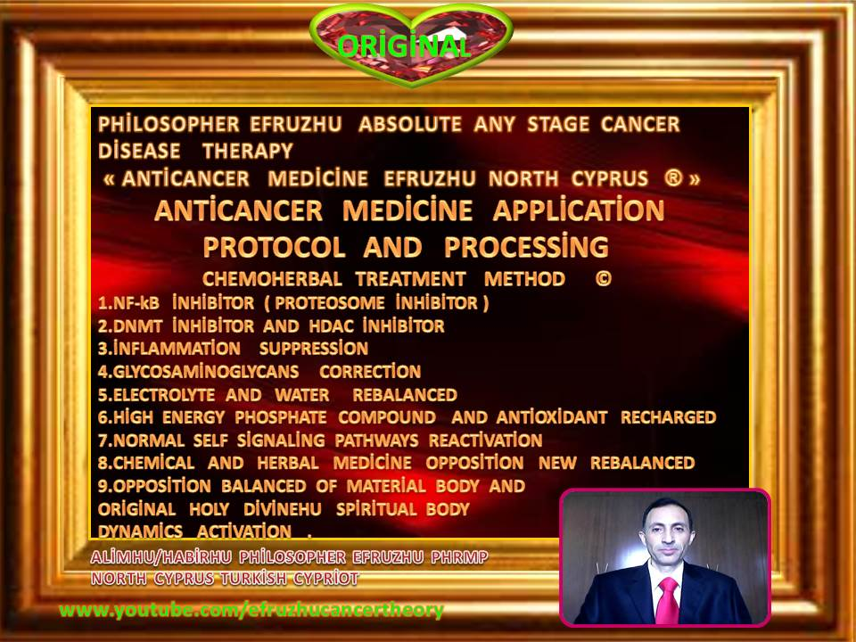

**efruzhu  cyprıus  turcıca (cyprum   turca)**

**“trıgemınus   clavıs  modus " (trıple  key  method)**

**1.maturatıon  2.apoptosıs  3.phagosıtosıs**

**(at   the   same  tıme)**

**absolute  any  stage   oncotherapy**

